Form CMS-2746 Date of Death Update
﻿
The Centers for Medicare & Medicaid Services (CMS) has made an adjustment to the date of death field on Form CMS-2746. Effective October 21, 2024, the date of death field cannot be edited directly on the Form CMS-2746 screen in EQRS. Changes to the date of death field must be made in the Medical Information section on the Patient screen in the patient's record in EQRS.
Additionally, the form will now display Submitted (by ) and the Submit Date displays at the top of the Form CMS-2746 screen in EQRS (Figure 1).
Figure 1. View of Death Notice Display in EQRS
RS Submission Schedule for:

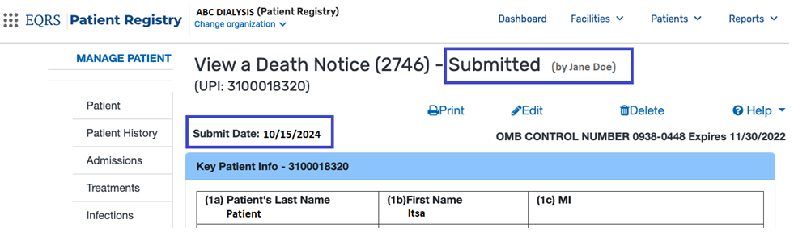

Please Note: The use of any Form CMS-2746 other than what is available in the End Stage Renal Disease Quality Reporting System (EQRS) is not authorized.
﻿For additional information on the Form CMS-2746 updates, refer to the Reference Guide: Form CMS-2746 Updates for a quick reference tool when completing Form CMS 2746. This resource is available on the Education page on www.MyCROWNWeb.org.
For assistance with EQRS technical issues, please contact the Center for Clinical Standards and Quality (CCSQ) Service Center. The CCSQ Service Center is open Monday-Friday 8 a.m. to 8 p.m. Eastern Time and can be reached via phone at 866-288-8912, email at qnetsupport-esrd@cms.hhs.gov, or online at the CCSQ Support Center.
For assistance with general EQRS and ESRD QIP questions, please contact the ESRD QIP Team via the QualityNet Q&A Tool.

